# ISO/IEEE 11073 Personal Health Device (X73-PHD) Standards Compliant Systems: A Systematic Literature Review (Sistemas que cumplen con los estándares ISO / IEEE 11073 Dispositivo de Salud Personal (X73-Phd): Una Revisión Sistemática de la Literatura)

**Abstracto:**

Desde la introducción de las normas ISO / IEEE 11073 para dispositivos de salud personal (X73-PHD), como parte de la familia de normas ISO / IEEE 11073, se ha aplicado a muchos sistemas de salud desarrollados para uso personal. En esta revisión sistemática de la literatura, revisamos la literatura existente recopilada utilizando tres bases de datos: Scopus, Pub Med y Web of Science. Proponemos una clasificación para los sistemas de salud personal en función de la ubicación en la que se utilizan, la tecnología utilizada para desarrollarlos y el propósito que determinan los usuarios objetivo. Encontramos que el 51% de los dispositivos utilizados en dichos sistemas están estandarizados, mientras que aproximadamente el 40% no lo están y cinco sistemas no especificaron el estado del dispositivo (9%). Se utilizaron diversas técnicas de adaptación para la estandarización. Además, el oxímetro de pulso es el dispositivo más utilizado en tales sistemas, ya que se usó en el 43% de ellos. Además, presentamos el papel de los estándares X73-PHD en Internet de las cosas (IoT) y los sistemas de telemedicina, discutimos los desafíos de utilizar este conjunto de estándares en los sistemas de monitoreo de salud y convertir los dispositivos no estandarizados en dispositivos estandarizados.. Finalmente, proponemos los requisitos de los sistemas de salud personal basados ​​en nuestra revisión de la literatura.

[***Tema:*** Multimedia móvil para el cuidado de la salud](https://ieeexplore.ieee.org/xpl/topics.jsp?isnumber=8600701&punumber=6287639&refinements=SpecialSection:Mobile%20Multimedia%20for%20Healthcare)

**Publicado en:**[Acceso IEEE](https://ieeexplore.ieee.org/xpl/RecentIssue.jsp?punumber=6287639)( Volumen: 7 )

**Página (s):** 3062 - 3073

**Fecha de publicación:** 14 de diciembre de 2018

**ISSN electrónico:** 2169-3536

**DOI:**[10.1109 / ACCESO.2018.2886818](https://doi.org/10.1109/ACCESS.2018.2886818)

**Editorial:**IEEE

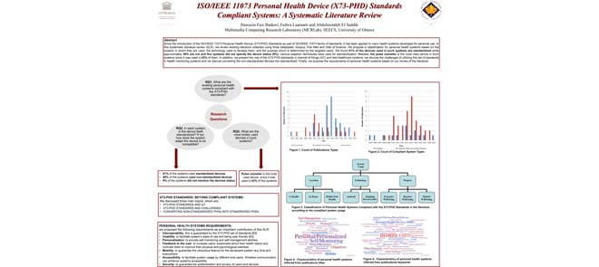

Este póster muestra el título del artículo, los autores con su afiliación y el resumen. Luego, muestra las preguntas de investigación y sus respuestas. Después de eso, muestra la discu... Ver más

Ocultar resumen completo

**SECCIÓN I.**

## **Introducción**

La explosión de Digital Twin [1], que incluye IoT y tecnología portátil y la disponibilidad de dispositivos de salud personal para el público en general, tienen un alto potencial para hacer que la atención médica sea mucho más eficiente en el futuro cercano. Con este desarrollo surge la necesidad de interoperabilidad para permitir servicios de salud más eficientes y reducir la complejidad tecnológica. Los estándares X73-PHD son el resultado de una colaboración entre la Organización Internacional de Normalización (ISO), IEEE y un grupo de fabricantes que surgió en un momento en que la necesidad de un estándar en este dominio nunca había sido tan alta.

Los estándares X73-PHD están destinados a dispositivos de salud diseñados para uso personal. Su objetivo es facilitar el intercambio de datos de salud al tiempo que proporciona interoperabilidad plug-and-play en tiempo real. Los estándares X73-PHD también proporcionan una solución de estandarización rentable para los sistemas de salud personal utilizados tanto por la comunidad de investigación como por la industria [2].

Varias investigaciones discuten los beneficios de los estándares X73-PHD para mejorar las capacidades de los sistemas de salud. Uno de los artículos de investigación iniciales a este respecto es el propuesto por Philips Research Europe [3]. Discute el anuncio del grupo de trabajo X73-PHD, justifica la necesidad de este conjunto de estándares y su papel en la resolución del problema de interoperabilidad en los sistemas de atención médica y elabora el modelo de datos y los formatos del contenido de los estándares.

Muchas investigaciones se centran en mejorar este conjunto de estándares como [4] y [5] para resolver problemas existentes y motivar su despliegue en los sistemas de salud. Barrón-González *y cols.*[4] intente adaptar las capacidades de control remoto de ISO / IEEE 11073 Point-of-Care (X73-PoC) a X73-PHD ya que no está cubierto en la versión actual de los estándares X73-PHD. Propusieron un paquete de extensión que permite al servidor modificar la configuración del dispositivo de forma remota. La investigación en [5], que es preparada por el presidente del grupo de trabajo X73-PHD, muestra el trabajo en curso para proponer estándares para más dispositivos de salud personal para alentar su utilización en los sistemas de salud.

La familia de estándares 11073 se ha utilizado ampliamente en muchas aplicaciones en sistemas de monitoreo de atención médica y se ha discutido en muchos informes de investigación [6] y libros [7], [8]. Algunas investigaciones comparan esta familia de estándares [9] con otros estándares en el campo de la salud. La investigación de estándares X73-PHD destaca la importancia de garantizar la interoperabilidad en el campo de la salud. La investigación en [10]muestra cómo se han construido los estándares X73-PHD basados ​​en los estándares X73-PoC y enumera los principales desafíos técnicos en la implementación del estándar. Estos desafíos son principalmente: control de flujo y errores, gestión de errores y alarmas, conexión de múltiples dispositivos médicos con uno o múltiples motores informáticos, o implantación en microcontroladores.

El desarrollo de los estándares X73-PHD para facilitar el aprovechamiento de los datos de salud recopilados ha sido alentado por el uso creciente de dispositivos de monitoreo de salud personal. Se han fabricado muchos dispositivos de salud personal (PHD) estandarizados, como el monitor de presión arterial, la balanza y la bomba de insulina. Actualmente, el uso de estos dispositivos es esencial para abordar la inactividad física ampliamente extendida y el rápido aumento de enfermedades crónicas como la diabetes y la hipertensión [11]. Los PHD permiten a las personas hacer un seguimiento de su estado de salud y administrar la ingesta de medicamentos, además de transmitir la información recopilada a los profesionales de la salud si es necesario [12], [13].

Manufacturers use different data formats and electronic features for health devices, which causes integration difficulties with healthcare information systems [2]. This motivated the IEEE and the International Organization for Standardization (ISO) to create a series of standards called ISO/IEEE 11073 Personal Health Device (X73-PHD) [14]. This series of standards aim to regulate the manufacturing of PHDs and control the interoperability among PHDs and systems [15]. A software development kit (SDK) is proposed in [16] to facilitate the adoption of the X73-PHD standards. Using such SDK could facilitate the standardizing task of personal health systems that depend on PHDs to perform their functions such as the system in [17].

In this review, our main objective is to survey the existing X73-PHD compliant systems that are developed for personal use and not for clinical use. Besides, we focus on the utilized devices in each system to determine if they are X73-PHD compliant or not. If not, we determine how the proposed systems adapt these devices to be compatible with the standards. Additionally, we aim to determine the most frequently used device in such systems. Such information is needed to support the trend towards developing standardized personal health systems.

In this paper, we include 11073-related research papers and exclude 11073-related products and patents because they had been covered by a metadata research [11]. Tang *et al.* [11] recommended the conducting of further research on papers since there is no systematic literature review, mapping or survey on the X73-PHD related research papers.

The rest of this paper is organized as follows:

Section II presents the research questions, then Section III discusses the scope and key terms. Section IV explains the SLR methodology and Section V presents the results. Section VI demonstrates the threats to validity. Section VII presents the relationship between the X73-PHD standards and IoT, the challenges faced by the utilization of this set of standards, and how to convert a non-standardized device into a standardized. Section VIII presents the requirements of developing personal health systems as an output of this review. Finally, Section IX concludes the paper.

**SECTION II.**

## **Research Questions**

To achieve the objectives of this SLR, we formulate the following questions:

1. What are the existing personal health systems compliant with the X73-PHD standards?
2. In each system, is the device itself standardized? If not, how does the system adapt the device to be compatible?
3. What are the most widely used devices in such systems?

**SECTION III.**

## **Scope and Key Terms**

In the following, we provide an overview on the X73-PHD standards, the key definitions and the literature scope.

### A. X73-PHD Standards: Background

The IEEE Standards Development Working Group (IEEE-WG) for PHDs defined the series of X73-PHD standards [15], which “addresses a need for an openly defined, independent standard for controlling information exchange to and from personal health devices and managers (e.g., cell phones, personal computers, personal health appliances, and set top boxes)”. This series of standards aims to regulate the manufacturing of devices as well as controlling the interoperability between devices and the systems [15]. Under this set of standards, each system consists of three principal models:

* Domain Information Model (DIM): for data representation
* Service Model (SM): for defining data accessibility and command methodologies
* Communications Model (CM): for data communication from an agent to a manager.

### B. Concepts Definitions

In this subsection, we propose definitions of the key concepts.

* **Personal Health Device (PHD):**

Many definitions can be found for PHDs. One of them is stated in [18] as “Personal Health Devices, wearable or not, are devices with constrained resources, specially related to energy supply and processing power”. This definition is from technical point of view and does not take the devices functionality into account. Thus, we define PHD as any device equipped with one or multiple sensors that are able to monitor vital signals of a person’s body possibly taking into consideration signals from surrounding environment such as noise.

* **Compliant Systems:**

They are personal health systems that adhere to the X73-PHD standards in manager sides by complying with the communication model (CM) of this family of standards as a minimum requirement and optionally with domain information model (DIM) and service model (SM) as a higher level of conformance. Starting from this point, we will use this concept to represent these targeted systems in this review.

* **Agent:**

In a personal health system, the device that provides the data is called an agent, which is usually the personal health device.

* **Manager:**

In a personal health system, the device that receives the data is called a manager. This can be a personal computer and a cell phone, etc.

### C. Inclusion and Exclusion Criteria

Incluimos diferentes tipos de publicaciones (revistas, conferencias, actas, talleres y libros) que consideran los sistemas compatibles. Además, intentamos incluir literatura existente relacionada con este conjunto de normas para proporcionar una revisión exhaustiva. Se excluyeron las publicaciones sobre productos y patentes relacionadas con 11073, ya que se cubrieron recientemente [11].

**SECCION IV.**

## **Método de encuesta**

Describimos la metodología en tres pasos: preparación previa a la encuesta, búsqueda sistemática y análisis posterior a la encuesta, de la siguiente manera:

### A. Preparación previa a la encuesta

Para responder las preguntas de investigación mencionadas anteriormente, seguimos una estrategia de "cultivo de perlas" de la siguiente manera:

* Para generar un conocimiento inicial sobre las publicaciones, buscamos el nombre de los estándares X73-PHD escrito en varios formatos utilizando la consulta completa que se muestra a continuación:

((TITLE-ABS-KEY ("IEEE 11073 Personal Health Devices" O "IEEE 11073 PHD Standards" O "ISO / IEEE 11073 PHD" O "X-73 Standard *" O "IEEE 11073 PHD" O "X73-PHD" O "Normas IEEE-X73")))

* Ejecutamos esta consulta exhaustiva en Scopus [19]. Encontramos un número relativamente pequeño de publicaciones (41 publicaciones). Este número es razonable considerando la nueva aparición de este estándar.
* Luego, ejecutamos varias consultas en PubMed [20]. Nos ayudó a seleccionar varios artículos que aparecían con frecuencia en los resultados de las consultas, como [21] - [22] [23] [24].
* Por último, agregamos más conceptos para ampliar el rango de búsqueda y cubrir más publicaciones relacionadas con X73-PHD. La ejecución de la consulta exhaustiva en Scopus dio como resultado las publicaciones relacionadas con X73-PHD que abordan diferentes temas como la seguridad y el IoT. Esos trabajos de investigación se presentan más adelante en la sección VII.

### B. Búsqueda sistemática

* **Seleccione las bases de datos de origen:** Seleccionamos Web of science [25] además de Scopus y PubMed para garantizar la cobertura de las publicaciones relacionadas.
* **Cree la consulta de búsqueda abstracta:** esta consulta se muestra en la Tabla 1. Muestra las partes principales de la consulta junto con la descripción y justificaciones de cada parte.

**TABLA 1** Consulta de búsqueda abstracta de SLR

[[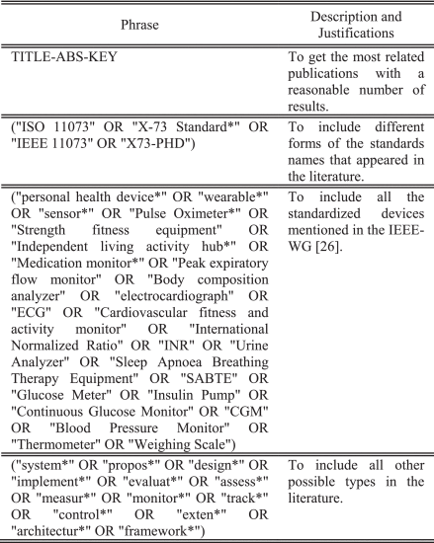](https://ieeexplore.ieee.org/mediastore_new/IEEE/content/media/6287639/8600701/8576505/badaw.t1-2886818-large.gif)](https://ieeexplore.ieee.org/mediastore_new/IEEE/content/media/6287639/8600701/8576505/badaw.t1-2886818-large.gif)

### C. Análisis posterior a la encuesta

Running the above queries on different source databases, following we collected automatically: title, abstract, keywords, and year. Additionally, we collected the following data manually:

1. **Compliant System Type:** shows if the proposed system in the publication is a complete system, which means a fully designed and implemented system, or it is a prototype.
2. **Compliant System Usage:**refers to the usage of the system proposed in the publication.
3. **Compliant System Characteristics:** refers to the characteristics that distinguish the proposed system. The publication’s title and keywords were used to extract the characteristics.
4. **PHD Type:** shows if the device(s) used in the proposed system is manufactured to be X73-PHD compliant or adapted by the system. “NA” entry was used when the device type was not mentioned.
5. **Adaptation Technique:** presents how the proposed compliant system adapted the device if it is not compatible with the X73-PHD Standards. “NA” entry was used when the technique was not mentioned.
6. **PHD Name:** shows the name of the device(s) in the system.

The following section demonstrates how the collected data were used to synthesis the answers to the three research questions.

**SECTION V.**

## **Literature Review Results**

We collected 106 publications. Then, we investigated them manually one-by-one as follow:

* Dos de los autores verificaron cada publicación independientemente considerando los criterios de inclusión y exclusión.
* Cada autor respondió individualmente a la pregunta: "¿esta publicación representa el alcance de la revisión?" seleccionando una respuesta: (Sí / No / No estoy seguro), y escriba comentarios o justificaciones si es necesario.
* Los autores realizaron una sesión de discusión para verificar sus selecciones y resolver conflictos.

Siguiendo estos pasos, obtuvimos 53 publicaciones que representan los sistemas compatibles específicos. La mayoría de estas publicaciones son artículos de revistas (62%), mientras que el resto son actas de congresos (36%) y solo 1 sección de libros (2%) [27]. La Figura 1 ilustra el recuento de tipos de publicación anualmente.

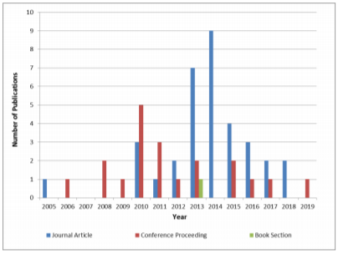

**FIGURA 1.** Recuento de tipos de publicaciones.

The answers of the three research questions are discussed in the following:

1. **What are the existing personal health systems compliant with the X73-PHD standards?**

To answer this question, we utilize the compliant system type, usage and characteristics as follow:

* + **Compliant System Type:**

We found that the majority of existing compliant systems are complete systems (approximately 74%) while the remaining are prototypes (approximately 26%). The first complete compliant system is a patient monitoring system proposed in 2008 [28]. A wearable home health monitoring system proposed in [29] is an example of prototypes. Figure 2 illustrates compliant system types. Mobile systems are mainly Android-based and represent 44% of the complete systems. Only one system is iOS-based system [30].

* + **Compliant System Usage:**

we found that the personal health systems can be classified based on the *location* where they are used, the *technology* used to develop them, or the *purpose*, which is determined by the intended users. Thus, we proposed the classification illustrated in figure 3 showing the classes and subclasses described in the following:

* + 1. LOCATION: Personal health systems could be classified as one of three subclasses as follow:
       - **U–Health:** Some research consider providing ubiquitous health services for patients as well as healthy individuals such as the system in [31]. In this review, this subclass refers to ubiquitous personal health systems that can provide health services anytime and anywhere. Systems in [21], [28], [32], and [33] are some examples of this subclass.
       - **In-Home:** Many research consider providing health services to serve patients at their homes such as [34] and [35] and enhance individuals’ well-being such as [36] and [37]. In this review, this subclass refers to personal health systems that are developed to be used at home for monitoring purposes. Systems in [22] and [38]–[39][40][41] are some examples of this subclass.
       - **Mobile/Tele-Health:** Many research utilize the mobile and tele-health technologies to accelerate health services provision for patients such as [42] and [43] and healthy individuals for their well-being such as [31]. In this review, this subclass refers to personal health systems that are developed to monitor patient’s health remotely. Systems in [30] and [44]–[45][46][47] are some examples of this subclass.
    2. TECHNOLOGY: Personal health systems could be classified as one of two subclasses as follow:
       - **Android:** Many systems implemented as Android applications to provide health and well-being services, such as systems in [31] and [48]–[49][50]. In this review, this subclass refers to personal health systems that are developed as Android applications or to interact with Android terminals such as smartphones or tablets. Systems in [23] and [51]–[52][53][54][55] are some examples of this subclass.
       - **Adopting Interoperability:** This subclass refers to personal health systems that are standardized by utilizing various techniques and protocols to fulfill the interoperability condition. Some examples of these techniques are: an agent with appropriate mapping methods between manufacturer and ISO/IEEE 11073 nomenclature systems [56], a standard message generation toolkit to easily standardize existing non-standard healthcare devices [57], and an implementation model of standardization [24]. Other examples are found in [58]–[59][60][61][62].
    3. PURPOSE: We proposed this classification to show the how personal health systems could be used for individuals’ well-being. Thus, we suggest that compliant systems could be classified as one of three subclasses as follows. Two of the subclasses names are derived from the linguistic meaning of “proactive” vs. “reactive” found in [63] and [64] to differentiate between healthy individual’s well-being and patient’s well-being.
       - **Proactive Well-being:** Refers to personal health systems targeting healthy individuals to track vital signs and promote healthy practices. Monitoring food intake and daily physical activity level are examples of these practices for healthy lifestyle. These systems may target adults [65]–[66][67] or children [68]–[69][70]. In this review, systems developed to monitor vital signs [2], [71] or physical activity level [72] are examples of this subclass.
       - **Reactive Well-being:** Refers to personal health systems targeting patients to monitor their health continuously and remotely. Some examples are systems developed for patients with chronic diseases such as diabetes [43], [73], stroke [74], [75] and obesity [76]. Other examples are systems found in [77] and [79]. In this review, systems developed to monitor cardiovascular diseases [79]–[80][81] or manage chronic diseases [82] are examples of this subclass.
       - **Hybrid Well-being:** Refers to personal health systems targeting individuals vulnerable to chronic diseases such as high blood pressure and pre-diabetes. Thus, this subclass includes practices from both other subclasses. Some examples are systems developed for stress management [48], [83], and monitoring elderly people. In this review, systems developed to monitor elderly people who are vulnerable to many diseases such as [22], [46], and [84]–[85][86] are examples of this subclass. Other examples are systems developed for postpartum well-being [87], and emergency cases [47], [62].

The type and usage of the collected compliant systems are shown in Table 4.

* + 1. Compliant Systems characteristics:

We analyzed the titles and keywords concepts of the publications to formulate a set of criteria that characterize the personal health systems. Figure 4 and Figure 5 show the word clouds generated from analyzing the titles and keywords respectively based on the frequency of each word using WordItOut [88].

Figure 4 emphasizes the top five characteristics of personal health systems, which are: being personalized, providing self-monitoring ability, being mobile and ubiquitous systems; following specific protocols such as the X73-PHD standards, and providing self-management ability. Other characteristics are: being wearable systems, utilizing biosensors and supporting interoperability. Figure 5 emphasizes the critical need of these systems to be standardized according to ISO/IEEE 11073 family of standards and to use one or multiple personal health devices.

1. **In each system, is the device itself standardized? If not, how does the system adapt the device to be compatible?**

We found most systems used standardized devices (51%) whereas the remaining used non-standardized devices (40%) and five systems (9%) did not mention the devices status, found in [10], [18], [28], [41], and [44]. Various techniques and protocols were used to adapt non-standardized devices. Table 2 shows some of these techniques.

1. **What are the most widely used devices in such systems?**

We found 18 different devices were used in the compliant systems. Most systems used more than one device for evaluation. Some of these devices were considered by the IEEE-WG [26]. They are pulse oximeter, blood pressure monitor, thermometer, weighing scale, electrocardiograph (ECG), independent living activity hub, and glucose meter. The non-standardized devices are physical activity monitors, bed sensors, chair sensors, medication dispenser, fall detection sensor, plethysmogram (PPG), pedometer, smart phone camera and sensors, smart shoe insole, which has been validated to measure gait parameters in [98], iPad system and Wii Balance Board as a weighting scale.

**TABLE 2**Some Techniques Used to Adapt Non-Standardized PHDs

[[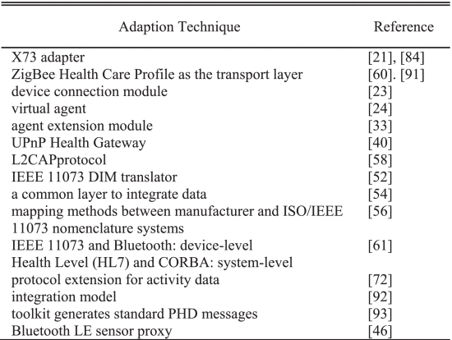](https://ieeexplore.ieee.org/mediastore_new/IEEE/content/media/6287639/8600701/8576505/badaw.t2-2886818-large.gif)](https://ieeexplore.ieee.org/mediastore_new/IEEE/content/media/6287639/8600701/8576505/badaw.t2-2886818-large.gif)

**TABLA 3.**  PHD diferentes utilizados en los sistemas compatibles en este SLR

[[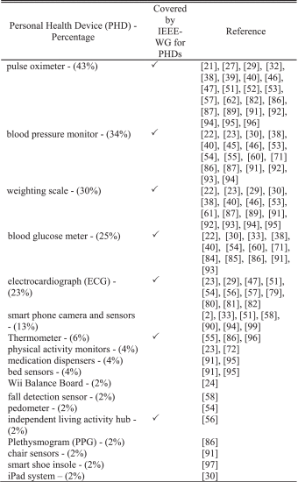](https://ieeexplore.ieee.org/mediastore_new/IEEE/content/media/6287639/8600701/8576505/badaw.t3-2886818-large.gif)](https://ieeexplore.ieee.org/mediastore_new/IEEE/content/media/6287639/8600701/8576505/badaw.t3-2886818-large.gif)

**TABLA 4.**  Una comparación de los sistemas que cumplen con X73-PHD según el tipo y el uso

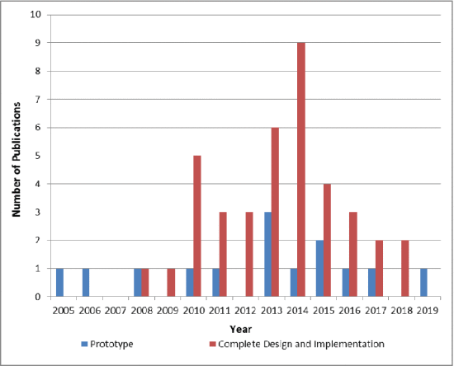**FIGURA 2.** Recuento de tipos de sistemas compatibles.

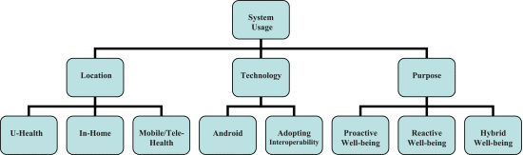

**FIGURA 3.** Clasificación de los sistemas de salud personal que cumplen con los estándares X73-PHD en la literatura de acuerdo con el uso del sistema compatible.

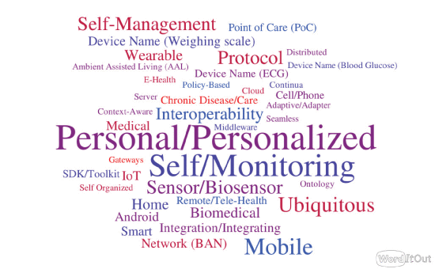

**FIGURA 4.** Características de los sistemas de salud personal inferidos de los títulos de las publicaciones.

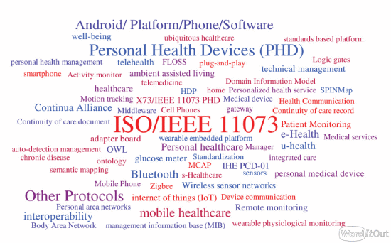

**FIGURA 5.** Características de los sistemas de salud personal inferidos de las palabras clave de publicaciones.

El dispositivo más utilizado es el oxímetro de pulso, que se utilizó en el 43% de los sistemas conformes. La Tabla 3 muestra los dispositivos utilizados en los sistemas compatibles en orden descendente de mayor a menor uso con los porcentajes.

**SECCION VI.**

## **Thrats to Validity**

Regarding the construct validity, following the steps stated in Section IV helped us to answer the research questions, document interesting findings and draw conclusions.

Regarding the internal validity, the authors selected the papers independently to minimize bias. Also, they discussed their selection to resolve conflicts and agreed on the final set of papers.

Regarding the external validity, the exclusion of products and patents publications could limit the generalization of the findings of this review.

**SECTION VII.**

## **X73-PHD Standards: Beyond Compliant Systems**

This section presents the X73-PHD research related to IoT, challenges, and converting non-standardized devices into standardized devices, as a result of running the comprehensive query.

### A. X73-PHD Standards and IoT

Many research consider developing health care systems utilizing IoT such as systems in [99] and [100]. A survey presented in [101] discusses this utilization extensively. Currently, the X73-PHD standards are strongly related to the IoT due to the proliferation of the IoT healthcare devices. This relationship leads to the emergence of many IoT-based personal health systems. One research [102] lists the evolving stages of IoT-based healthcare architecture and systems. These four main stages include the IEEE 11073 health standard based architecture. These four stages also support the proposed system in [103]. In addition, the research in [104] highlights the relationship between the X73-PHD standards and “IoT health” vision. It proposes a portable, open-source implementation of the IEEE 11073-20601 stack called Antidote to increase the visibility of this standard in IoT health applications. This research was initiated in [105] where a conformance testing framework was generated for the communication model of the X73-PHD standards.

Interoperability is one of the main issues in IoT healthcare communication systems. A recent research [106] addresses this issue. It discusses the complexity of implementing the suggested method to exchange healthcare data in the data model of the X73-PHD standards when using it in the resource-constrained IoT healthcare devices. To solve this issue, the authors designed and implemented a communication system aiming to integrate the X73-PHD standards in IoT. Another research [107] addresses this issue and shows how utilizing the X73-PHD standards can help solve it. A similar research [108] reflects the importance of utilizing the X73-PHD standards between the devices in IoT healthcare services to improve the interoperability and reduce data loss while transmission. It considers this utilization a potential solution for the common challenges of IoT devices such as limited power supply, CPU capacity, and memory in addition to the challenges of IoT constrained network performance such as bandwidth, wireless channel, throughput, payload, etc.

### B. X73-PHD Standards and Challenges

This subsection presents the deployment challenges facing the X73-PHD standards in health systems. Then, it discusses some of the challenges faced by personal health systems and how using this set of standards can help in solving some of them.

This set of standards does not address security or any other related challenges such as the authentication of medical devices and users privacy. Many research tackle these challenges due to its importance in the integrity of the tele-healthcare systems while utilizing the X73-PHD standards.

A research in [109] proposes a system developed to serve frail elderly. It uses the Near-field communication (NFC) technology as a validation method for system users. A blood pressure monitor was modified with an NFC scanner to be used with an NFC card for identification purposes. Other research proposes a possible security model for remote patient monitoring devices in [110] to overcome these challenges.

In addition to using NFC technology as a potential solution for lack of security and authentication methods in the X73-PHD standards, a research in [111] proposes a design and implementation of security policy within the standards. It uses Asymmetric-Key Cryptography and the RSA algorithm as the digital signature scheme. Other research in [112] summarizes the latest findings in the development of tele-healthcare monitoring systems in Russia using standardized devices, and proposes a compliant secure personal health system.

The set of the X73-PHD standards contributes to solving some of the personal health systems challenges. It plays a critical role in the efficiency of real-time monitoring services, where continuous collection and transmission of large amount of vital health data such as ECG data is fundamental.

In addition to solving the interoperability between agents and managers, the X73-PHD standards paved the path toward developing reliable real-time systems able to transmit big amounts of data from the manager to any remote server [113]. This system proposes an extended agent and manager for data compression while maintaining the compatibility with the X73-PHD standard for ECG. It reflects the importance of developing compatible personal health systems, which helps overcome several challenges such as a limited wireless capacity and unstable channel conditions.

Other than the interoperability between agents, managers and remote services, there is also a need to address the interoperability between various types of data and the multimedia content in real-time monitoring systems. One research discusses this point in [114].

Cloud-based multimedia services such as in [77] and [115]–[116][117] consider an efficient model of remote supporting services in personal health systems due to the multimodality nature of health data such as vital signals and medical images.

### C. Converting Non-Standardized PHDs Into Stnadrdized PHDs

Several research propose various suggestions to standardize common personal devices used extensively in the health field. The reason is that the majority of existing devices do not yet comply with the X73-PHD standards. Some research explain the standardization process for devices in general such as [118] and [119] while others explain the process for specific devices such as [120]–[121][122][123].

The research in [118] and [119] suggest developing a Universal PHD Adapter (UPA) and an UPA interface board to be used in home healthcare services. They proposed the standardization of a glucose meter, a weight scale and a blood pressure monitor. Standardizing the ECG as a personal health device was one of the earliest attempts [120], [121]. Research in [122] discusses the storage and transmission of ECG signals messages, while research in [123] proposes Integrated Healthcare Information System (IHIS) to provide end-to-end standardization for digital ECG signals formats.

**SECTION VIII.**

## **Personal Health Systems Requirements**

Analyzing the results collected through this review enabled us to identify the key requirements for designing and developing personal health systems. Based on the characteristics inferred from analyzing titles, and keywords in the answer of RQ1, and from reviewing the literature of the X73-PHD standards, we propose the following list of requirements:

* Interoperability: this is guaranteed by the X73-PHD set of standards [82].
* Usability: to facilitate system’s ease of use and being user friendly [82].
* Personalization: to provide self-monitoring and self-management abilities.
* Feedback to the user: to increase users’ awareness about their health status and motivate them to improve their physical and psychological wellness.
* Movilidad: para garantizar la característica ubicua del sistema desarrollado en cualquier momento y en cualquier lugar.
* Accesibilidad: para facilitar el uso del sistema por diferentes usuarios finales. La comunicación inalámbrica puede mejorar la accesibilidad de los sistemas.
* Seguridad: para garantizar la autenticación y privacidad de usuarios y dispositivos.

**SECCION IX.**

## **Conclusión**

En este artículo, proporcionamos una revisión bibliográfica sistemática de investigaciones relacionadas con los estándares X73-PHD. Revisamos los sistemas de salud personal que cumplen con los estándares X73-PHD e ilustramos los hallazgos que sintetizamos a partir de los datos recopilados sobre los tipos, el uso y las características de los sistemas compatibles. También propusimos una clasificación del uso de los sistemas compatibles en función de la ubicación, la tecnología y el propósito del uso. Descubrimos que la mayoría de estos sistemas utilizaban dispositivos estandarizados y el oxímetro de pulso es el dispositivo más utilizado. Además, discutimos la relación entre los estándares X73-PHD e IoT, los desafíos de implementación que enfrentan los estándares X73-PHD y la conversión de dispositivos no estandarizados en estandarizados. Finalmente, concluimos enumerando los requisitos de los sistemas de salud personal.

## **lista de abreviaciones**

Abreviatura Expansión

|  |  |
| --- | --- |
|  | Dispositivo de salud personal |
|  | ISO / IEEE 11073 |
|  | Equipo de terapia respiratoria para la apnea del sueño |
|  | PLETHISMOGRAMA |
|  | Punto de atención |
|  | Revisión sistemática de literatura |
|  | Internet de las Cosas |
|  | Kit de desarrollo de software |
|  | Modelo de información de dominio |
|  | Modelo de servicio |
|  | Modelo de comunicación |
|  | Nivel de salud (protocolo sanitario) |
|  | Grupo de trabajo de desarrollo de normas IEEE |
|  | Electrocardiografía |
|  | Adaptador PHD universal |
|  | Sistema Integrado de Información de Salud |
|  | Razón normalizada internacional |
|  | Monitor continuo de glucosa |

### RECONOCIMIENTO

Los autores agradecen al profesor Daniel Amyot por su ayuda y sus conocimientos en las primeras etapas de la realización de esta SLR.